Experiment-7

**Activity – 4**

1. Display 1 to 5 students details

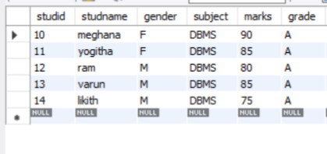

2. Display who got grade A

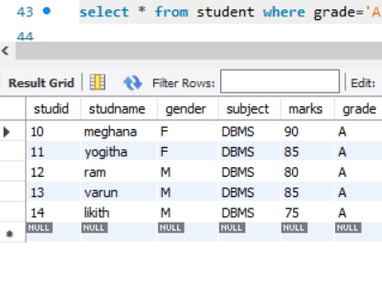

3. Display whose marks is less than 50

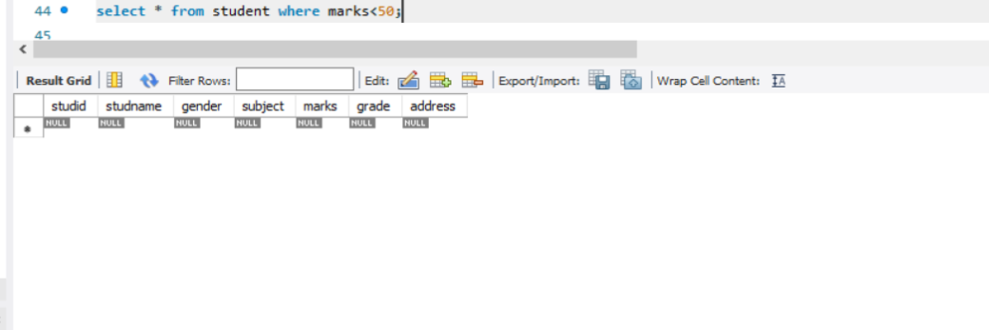

4. Display student id and name

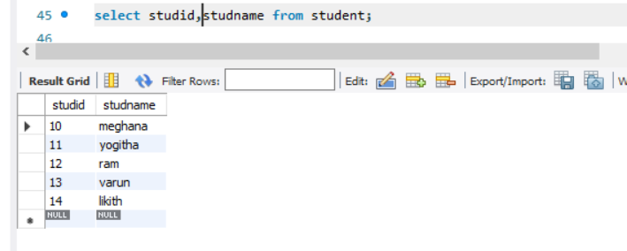

5. Display the student id and name whose mark is 50 to 60 and female.

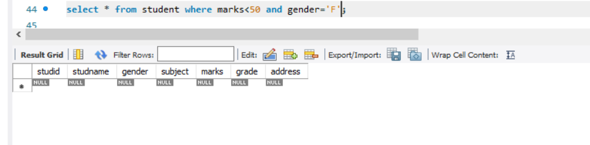

6. Display the list of students who gets greater than 70

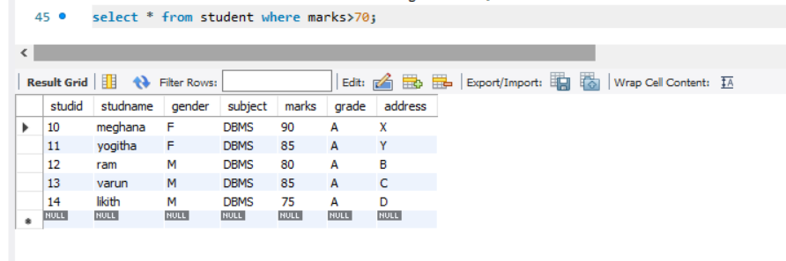

7. Delete the failure students and display complete table.

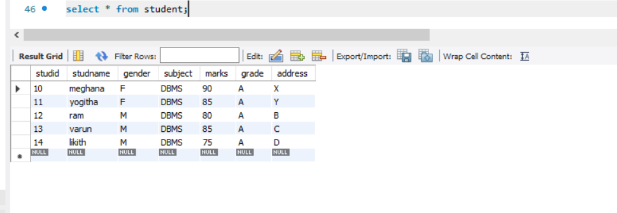

8. Display activity id, name using object

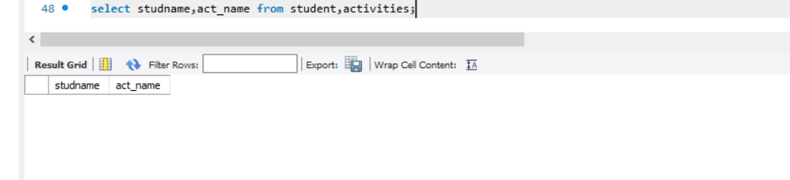

9. Add course to student table then insert values .Display student id, faculty id using course name condition with object

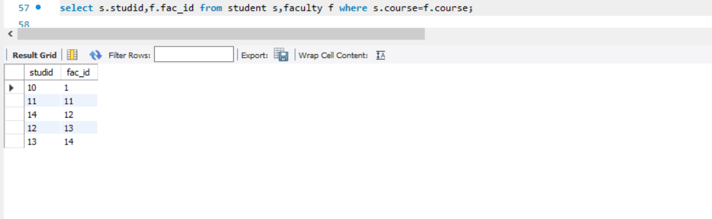

Activity – 5

1. Change mark to 50 whose id is 4

2. Change name whose id is 3

3. Change activity name whose id between 5 to 7

4. Change department section to A whose id is less than 5

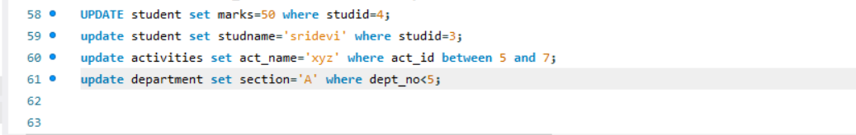

5. Delete row who has id = 3

C:\Users\ASUS\Desktop\del.png

6.Select student name and mark from student and faculty name from faculty

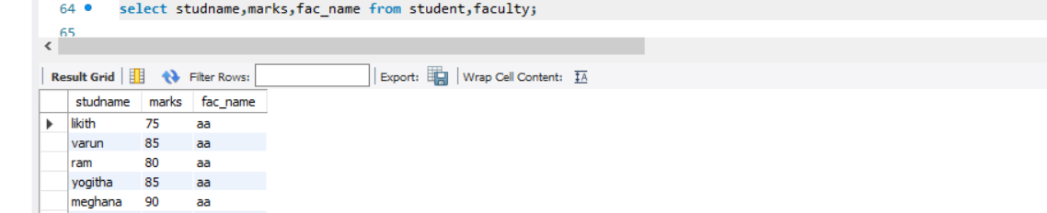

Activity – 6

1. Select department starts from ‘c’ and faculty name ends with f

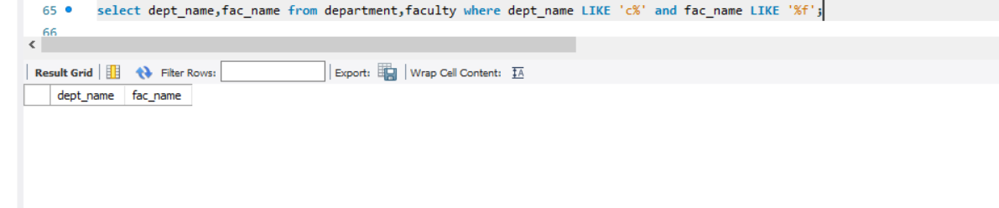

2. Select activity having characters between ‘ct’

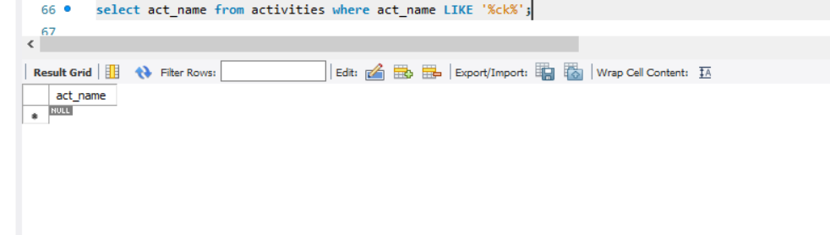

3. Display students list descending order of student id

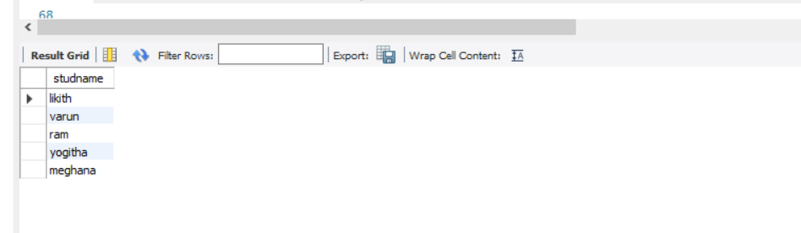

4. Display faculty name ascending order

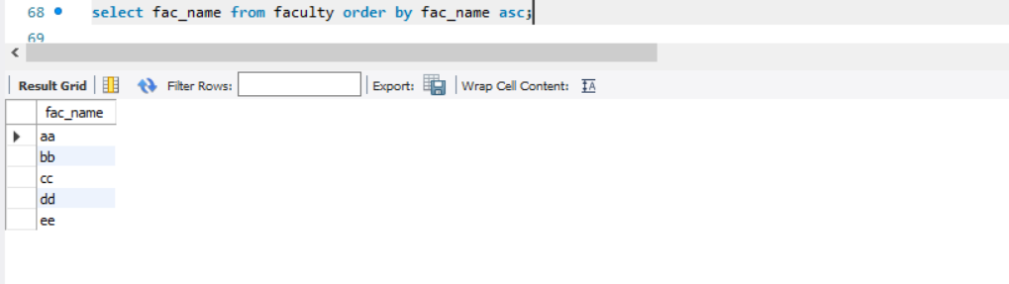

5. Display students list based on grade

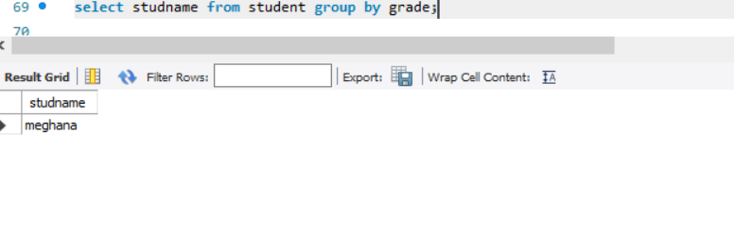

6. Display students having grade a using group by

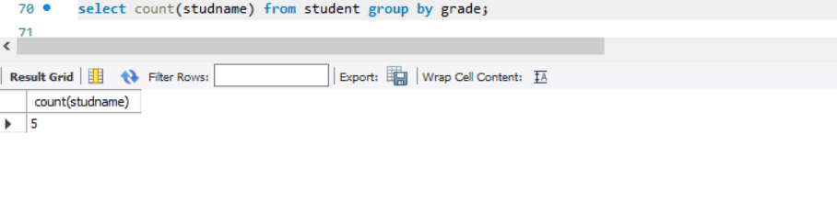

7. Group by faculty id and display

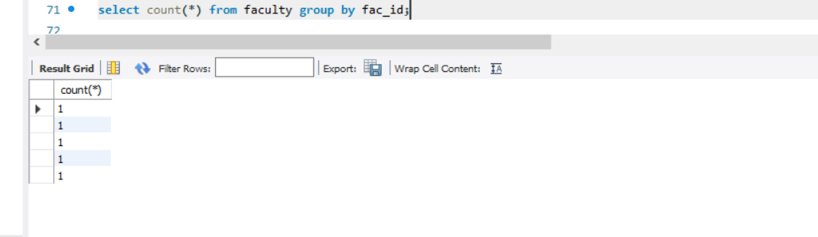

8. Display the students list whose grade is A using having

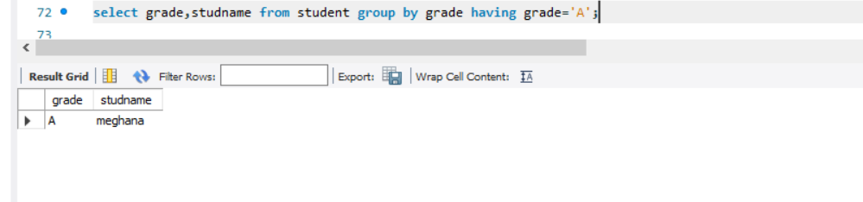

9. Display the faculty list who are teaching subject pps

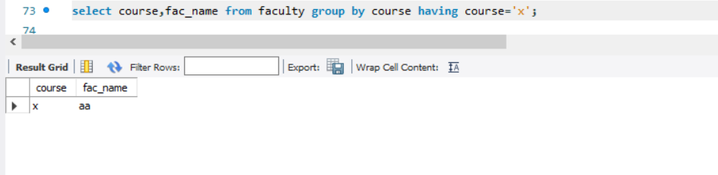

10. Apply aggregate functions in students marks- min, max, sum, count, avg

